CCNA1 Hands-on skills integration lab.
michael.ferrie@edinburghcollege.ac.uk
Student Name:
Date:
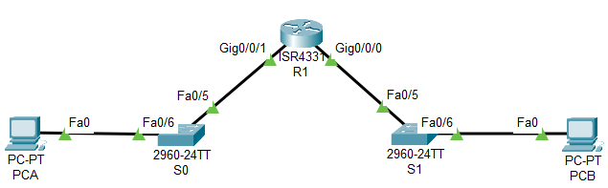
Network Diagram

Part A: design IP addressing Scheme and cable network.
- Given an address space of 192.168.100.0/24, create two networks, network A should have capacity for 25 hosts and network B should have capacity for 4 hosts. Complete the addressing table first.
 | Network A | Network B
Subnet address binary
Subnet address decimal
Mask binary
Mask decimal
Number of network bits decimal
Number of host bits decimal
Broadcast binary
Broadcast decimal
First useable decimal
Last useable decimal

- Cable the network as shown in the diagram.

Part B: Populate Addressing Table
- Assign the first useable IP address in each subnet to a router interface. Network A via G0/0/1 and Network B via G0/0/0.
- Assign the last useable IP address in each subnet to the PC NIC.
- Assign the second IP address in each subnet to each switch SVI.
- Use the ip default-gateway command on each switch to set the default gateway.
Device | IP Address | Subnet Mask | Gateway
R1 G0/0/1 |  |  | N/A
R1 G0/0/0 |  |  | N/A
S0
S1
PCA
PCB

Part C: Configure Device Settings and SSH
- a. Set the IP addresses, masks and gateways on each device using the addressing table from part B.

- a. Disable DNS lookup on R1, S0 and S1
b. Configure router hostname using the name R1.
c. Configure switch hostnames using the name S0 and S1.
d. Configure an appropriate banner on R1, S0 and S1.
e. Allow console logins with the password CiscoPa555!
f. Shutdown all unused switchports on S0 and S1.

- a. Set the encrypted privileged EXEC password to CiscoPa555!
b. Encrypt all plaintext passwords
c. Set minimum password length to 10 on R1.

- a. On R1, S0 and S1, configure ec.com as the domain name.
b. Configure a local user admin with the encrypted password CiscoPa555!
c. Set login on vty lines 0 4 to use local database.
d. Configure the vty lines 0 4 to accept SSH access only.
e. Generate an RSA crypto key using 1024 bits modulus.
f. Set the SSH version to 2.0.

Part C: Verify Network Connectivity and Configuration
Add a screenshot of the following to this document.
- Pings From PCA a to R1.
Add screenshot here.
- Pings From PCB a to R1.
Add screenshot here.
- Pings From PCA a to PCB.
Add screenshot here.
- The output of show run on S0, S1 and R1
Paste output here or each device here.

